17.0 A-1 BMD Workshop A-1 Minutes
5.19.2026 |  | 10:00AM – 11:00AM CST
Team | SCV2 Team
Facilitators | Jose Diaz
Note taker | Taylor Ilov
Attendees | SCV2 Team
Notes:
CREATE BUSINESS MASTER DATA

Business Partner Role Mapping
All customers in ECC are created as a Contact Person (not replicating to Sold to party in CRM)
Sold to is correct

BPs created in ECC for relationships
Only contact to contacts
No Contacts to sold 2
Can’t create contact person in CRM

List of fields not being utilized today, but want to map to Service Cloud (Discovered in exercise with Simple MDG)
à Currently the information is received from a 3rd party (Sends to a Data Lake, not stored in SAP) instead of their internal BPs
Ex Industry Sector à want the field available in Service Cloud.
(Max 150 fields In cloud)

Creating Energy/Non-Energy Business Agreements à do CSRs need this?
Heather W. said she’s always been able to transfer to an existing account (usually someone always has a 2nd account)
Utilizing if customer moved in, and need second account to temporarily transfer funds into.
Can’t transfer to account that is reversed

Customer billing, corporate billing,
WAM Team uses back office, so don’t use this

Billing team à has had to move money to a temporary account to complete adjustment on existing account, have to find an inactive account number to move it over to

Fraud rebill, cancel back and remove contract account. If there were payments you need to move off to reverse the bills, then reverse the contracts (Billing Agent does this) à could come in as a Fraud Agent or Ema case that comes in, front office case from call center

Telephone validation – custom tables created

List of fields not being utilized today, but want to map to Service Cloud (Discovered in exercise with Simple MDG)
à Currently the information is received from a 3rd party (Sends to a Data Lake, not stored in SAP) instead of their internal BPs
Ex Industry Sector à want the field available in Service Cloud.
(Max 150 fields In cloud)

MAINTAIN BUSINESS MASTER DATA

Vaps à either keep or transform, will need to sit down and discuss this. If we remove VAPS and they’re not marked as Info Release à Do Not Solicit, will have to mark them as Info Release

- Transfer to HSA at the end of call, if marked as Do Not Solicit VAPS, then they can not transfer.
- As long as it is Do Not Solicit to anything and Contact Center Agents see this
- Just need to make sure there is an alert.
- Do Not Solicit Vaps triggers this (not info release)
- If we go with Info Release, we want Info release to trigger it
- Original Intent: Customers that didn’t want ASP or to be moved to the movers program
- Comet Uses Info Release à what happens to Comet after?
Required on every call to transfer, not just move ins
- Not everyone that has Info release checked has VAPS do not solicit checked
- oncourse Home Solutions (offer services in addition to the move in)
- (SNP could do this)
- Do not solicit alert will be as a flag up top along the move in

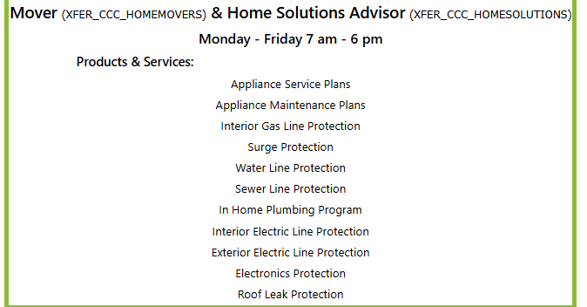

DO NOT SOLICIT FIELDS
- Don’t solicit
- Via mail
- Via telephone
- Via VAPS

Instead of DO Not Solicit VAPS à use standard info release field, configure another option but customize the alert to look at that option
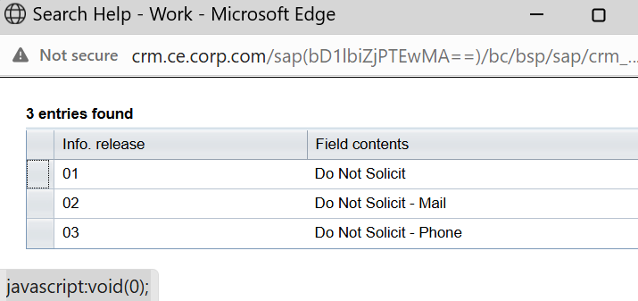

Employee Classification à needed. Not maintained as a relationship
Still audit employees to see if they are coded, happens at hiring process

BCC Shut Off Notice Suppression – Kept

Code of Consent- how the fields are being populated

Maintain Business Agreement
- Maintain Business Agreement à Business Agreement fields should be visible to all roles but not editable
- Business Center edits these fields every day à add Care of lines, Bill Trust, etc.
- Who and how many times the Business Agreement fields are being changed – Dawn and Shibbu
- CAA2 – Billing backoffice
- Payment Terms is editable à opens up pop up based on Customer CSDD (Customer Select Due Date)
- Most CSR agents know how to make these changes via back office

Jose to Identify custom fields in Business Agreement Screen (Return bill, return notice, alt notice, payment terms, etc.) à

Customer Account Factsheet à ASP Identifier, Cover in Agent Desktop Experience Workshop
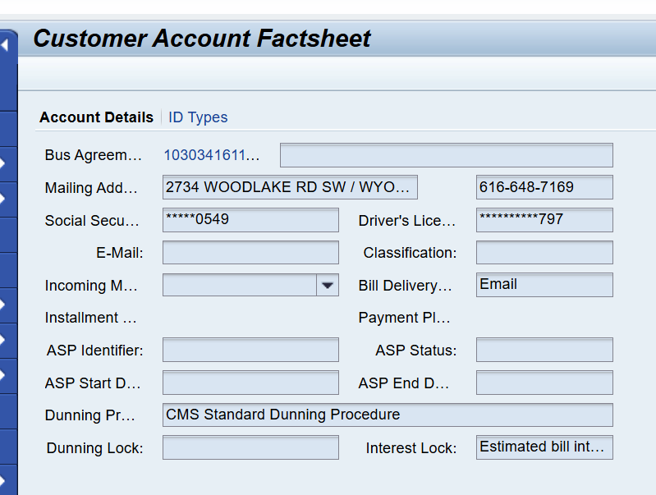

Key Decisions/ Outcomes :
- Allowing agents to create contact persons directly in service cloud -Change Impact

- Removal of Creating Energy/Non-Energy Business Agreements (outside of the Move out process) à this will be a back-office decision

- List of fields not being utilized today, but want to map to Service Cloud (Discovered in exercise with Simple MDG)

- Instead of DO Not Solicit VAPS use standard info release field, configure another option but customize the alert to look at that option (need to revisit the REASONS behind driving the alert, Do Not Solicit as overall clean up)

- Removing Code of Consent and Data Privacy field for future state Agents aren’t using this today

- Maintain Business Agreement à Business Agreement fields should be visible to all roles but not editable to all roles; need to have further conversations on this to figure what teams are using and how often so we can determine if we can move this to a backend overall process (Jose to Identify custom fields), Users still allowed to complete the CSDD enrollment

Parking Lot
Case Management Workshop: (Taylor add this to agenda so we are sure to cover)
Creating Energy/Non-Energy Business Agreements (outside of the Move out process)
Heather W. said she’s always been able to transfer to an existing account (usually someone always has a 2nd account)
Utilizing if customer moved in, and need second account to temporarily transfer funds into.
Can’t transfer to account that is reversed
Customer billing, corporate billing,
WAM Team uses back office, so don’t use this

Security roles not ready by PDD approval

Discuss on A-2 Workshop- Susi’s comment for display Dunning: I recall that SvcCloud has a standard view for dunning based on collection strategy, which we are moving to in S4. we may need to revisit once dunning configuration is in place

Extracting notes from the CRM Tables, make this as part of the Mock effort? – Taylor add action item
Action Items |  |  |  | Person Responsible | Deadline
( Create Person BP in CRM: Topic) Address dependent landline mobile email à need to have a discussion on independent vs dependent, need to figure out what fields need to be present |  |  |  | Dawn and Jose | 6/11 (WS B)
Jose test Suffix VS Prefix in Dev |  |  |  | Jose | 6/11 (WS B)
Shibbu and Dawn confirm Identification types + Relationships + Business Partner roles discussed will be configured in V2 |  |  |  | Dawn and Shibbu | 6/11 (WS B)
Adding tasks in ADO for verifying the fields that are being brought over – Taylor see Dawn’s comments in 17.0 A-1 Workshop Deck |  |  |  | Taylor – tag to Dawn and Shibbu | 5/28 (WS A-2)
Taylor update CAM Zone in ADO, resolved add comment– Custom Field will be necessary– jose confirm if Bp type is standard in V2 |  |  |  | Jose | 5/28 (WS A-2)
Code of Consent- how the fields are being populated, add task in ADO for potential decision |  |  |  | Taylor | 6/11 (WS B)
Adding Info Release to Org BP à promote the Task that DAWN inputted the information in to a potential decision from a regular task |  |  |  | Tayor | 6/11 (WS B)
Who and how many times the Business Agreement fields are being changed |  |  |  | Dawn and Shibbu | 5/28 (WS A-2)
Jose to Identify custom fields in Business Agreement Screen (Return bill, return notice, alt notice, payment terms, etc.) à Another process adds values to these fields + Contracts |  |  |  | Jose drop In deck from what Dawn said | 5/28 (WS A-2)
Need to confirm Data tables and how many years back of history we will have to go back in years (at least 7 years, potentially 10). What is being brought in (anything financial, have to go back at least 6 years), follow up transactions needed to load? |  |  |  | Dawn – already started with Shibbu | 6/11 (WS B)
Extracting notes from the CRM Tables, make this as part of the Mock effort? – Taylor add action item in ADO |  |  |  |  | 6/11 (WS B)

